**COMP 1632 Systems Development Project**

|  |  |  |
| --- | --- | --- |
| Name | ID | Percentage |
| Joshua Bennett | 000983229 | 20 |
| Matthew Peter Dredge | 000935649 | 20 |
| Wayne Edward Harvey-Pilot | 000933367 | 20 |
| Madalin-Cristian Preda | 000937119 | 20 |
| Thomas Lee Stoyles | 000990057 | 20 |

Contents

**Design Artefacts** 3

UML used case diagram 3

Interaction diagram 3

State chart diagram 3

Design UML 3

**Design Patterns** 3

**Design/Implementation problems** 3

**Evaluation of HCI factors** 3

**Work Breakdown form** 3

**Appendix with code and team meetings (minutes)** 3

**Individual report** 4

**Personal Review** 4

# **Design Artefacts**

## UML use case diagram

This is our groups UML use case diagram. Within the diagram we have clearly identified the primary and secondary actors within our system. Not only this we have clearly annotated where necessary within the diagram, so you are able to see which use case extends and which one includes.

## Interaction diagram

## State chart diagram

**Book Seat**

**Performance**

**User Controller**

**Booking**

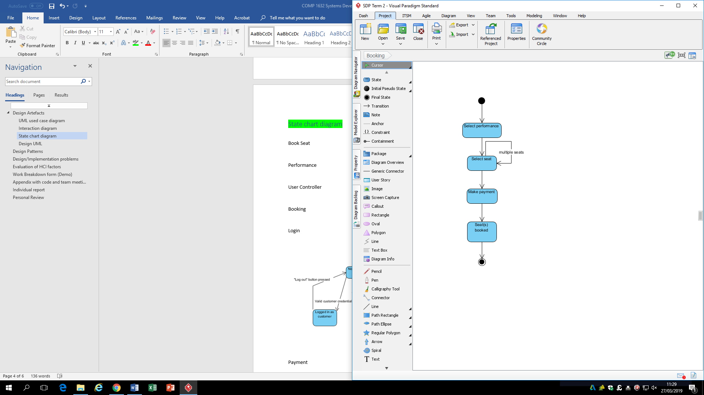

Here is the

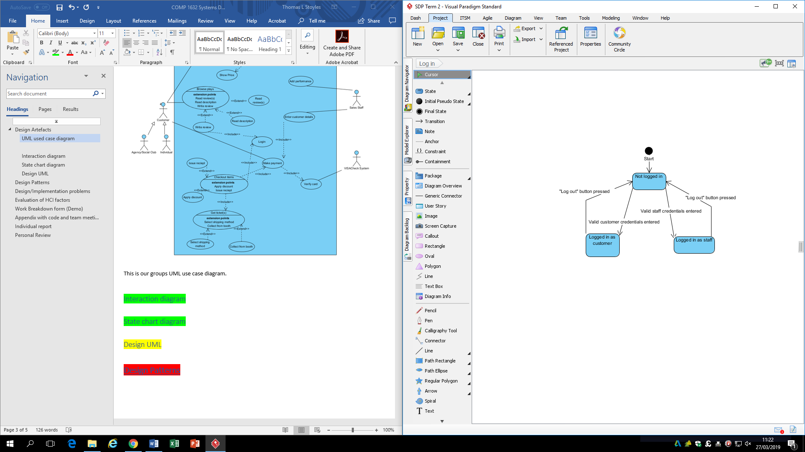**Login**

**Payment**

**Basket**

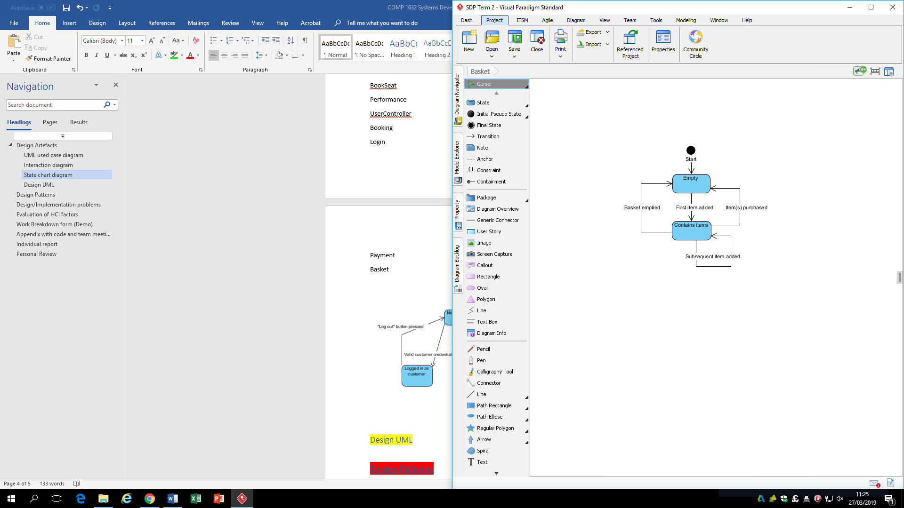

## Design UML

# **Design Patterns**

# **Design/Implementation problems**

# **Evaluation of HCI factors**

# **Work Breakdown form (Demo)**

# **Appendix with code and team meetings (minutes)**

# **Individual report**

YOUR NAME AND ID

# **Personal Review**